FAMOUS AUTHORS: THE BRONTE SISTERS
WRITING PROMPTS

Instructions: Below you will find writing prompts based on the video you watched. Only #6 requires any outside materials. Write everything you know about each prompt! Unless you write very small, I probably haven’t given you enough room; therefore, feel free to add space as needed.
Poor Bramwell: All those girls and just one bathroom. Give info about the Bronte family (names/birth order/years etc)

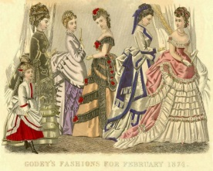

When I grow up, I want to marry a preacher! Tell a bit about Dad and Mom Bronte.

Is this school or prison?

DUMB THINGS THAT WOMEN DO TO MESS UP THEIR LIVES: Lessons from the Bronte Sisters

- Fall in love with a married man

- Isolation…Really Em? Animals, family, and Moors?

- Simple Economics: Putting all your financial eggs in one basket-not a good idea. (Hint: school)

- Bad boys aren’t good heroes: You aren’t doing your brother any favors.

- Imaginary world is cool, but there’s a real world out there and dying is no way to live in it!

- The Great Exhibition of 1851: Wait a minute: Didn’t I see that at Disney World?

- Charlotte, dear, you aren’t getting any younger. How many times does a man have to ask and besides, marriage has some great benefits!

AND THE NOT SO DUMB:
- Thanks, girls, for not settling for society’s image of womanhood!

